**Phase 1 – Project Virtual key for your repositories**

* **Project Description :**

As a Full Stack Developer, complete the features of the application by planning the development in terms of sprints and then push the source code to the GitHub repository. As this is a prototyped application, the user interaction will be via a command line.

* **Developer’s Details**
* Developer name: Chirag Agarwal
* Course: Java Full Stack Developer
* Github link: https://github.com/chirag627/virtualkey-project-phase-1
* **Sprint Planning and task completion:**

Number of Sprints: 1 and task completed are as follows:

1. Designing the workflow of the project
2. Creating a git repo where the project to be pushed
3. Developing the java project
4. Testing the project
5. Pushing the project on github

* **Algorithm:**

Step 1: Start

Step 2: Print the name of the project and developer details at the top of the console

Step 3: Print the options of the main menu

Step 4: if user press 1 then read the file names from the directory and

sort the list of files according to their names in ascending

order.

Step 5: if user press 2 then show the sub menu options

Step 5.1: In submenu if user press 1 then then ask user to enter the

name of file to create, if file already exists then show

exception.

Step 5.2: In submenu if user press 2 then then ask user to enter the

name of file to delete, if file doesn’t exists then show

exception.

Step 5.3: In submenu if user press 3 then then ask user to enter the

name of file to be searched, if file doesn’t exists then show

“File not found” and if file exists then show ”File found”

Step 5.4: In submenu if user press 4 then navigate user to main

menu

Step 5.5 In main menu if user press 3 then exit the program

Step 5.6 Stop

* Flow chart of the system

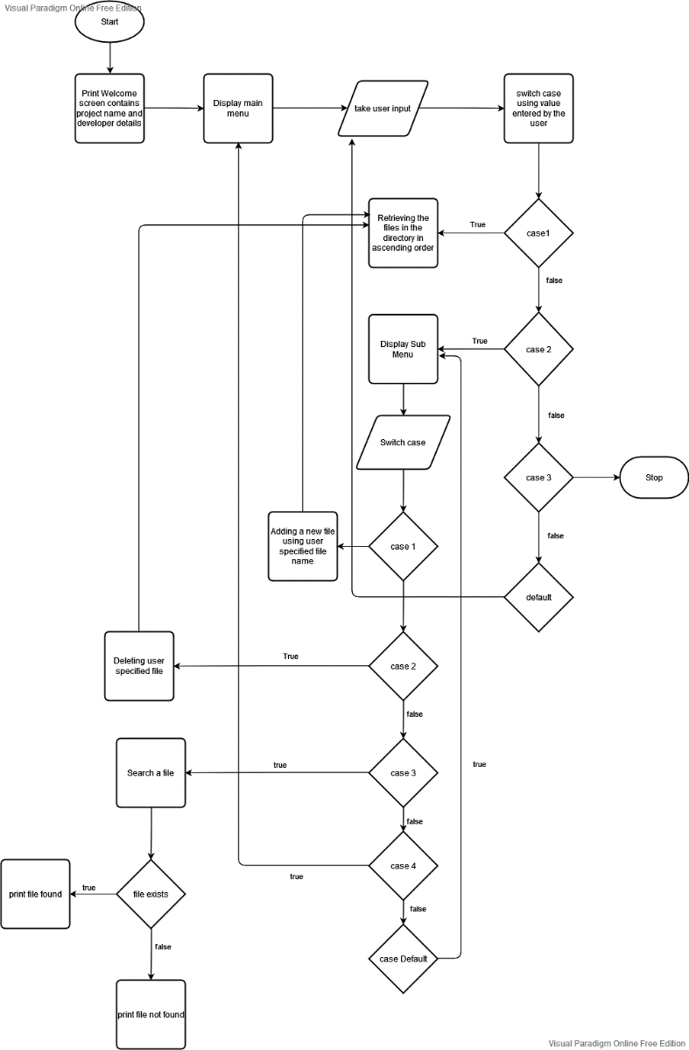

* Concepts Implemented
* File Handling
* Switch case
* Exception handling
* Collections
* Linear Search
* Bubble sort
* Github Link: <https://github.com/chirag627/virtualkey-project-phase-1>
* ScreenShots of the program

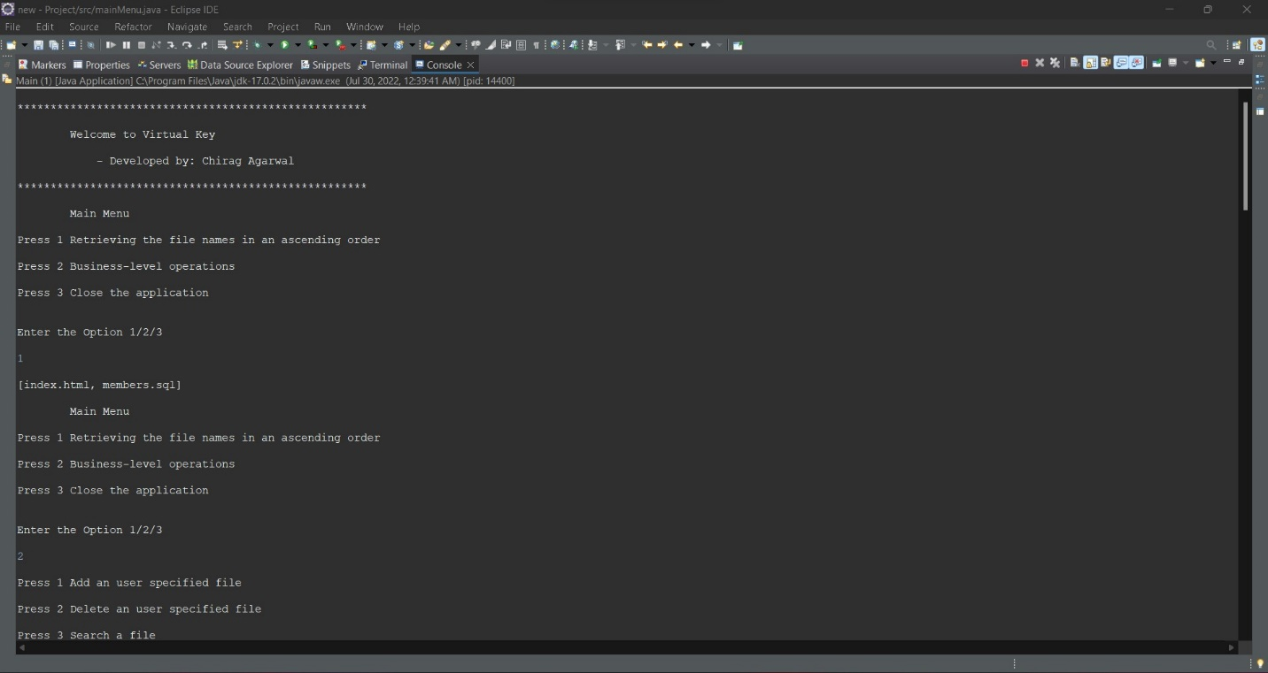

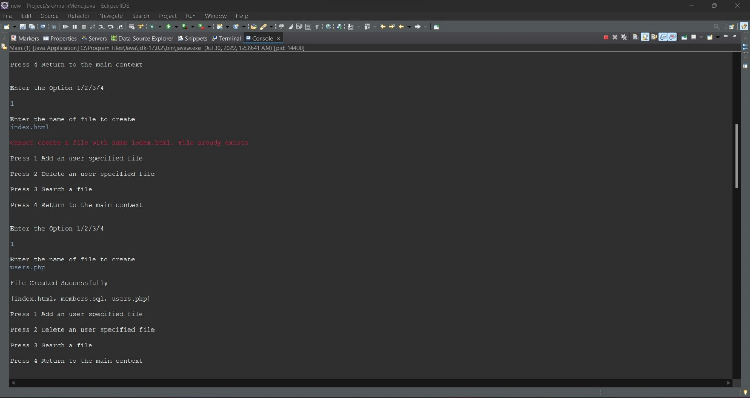

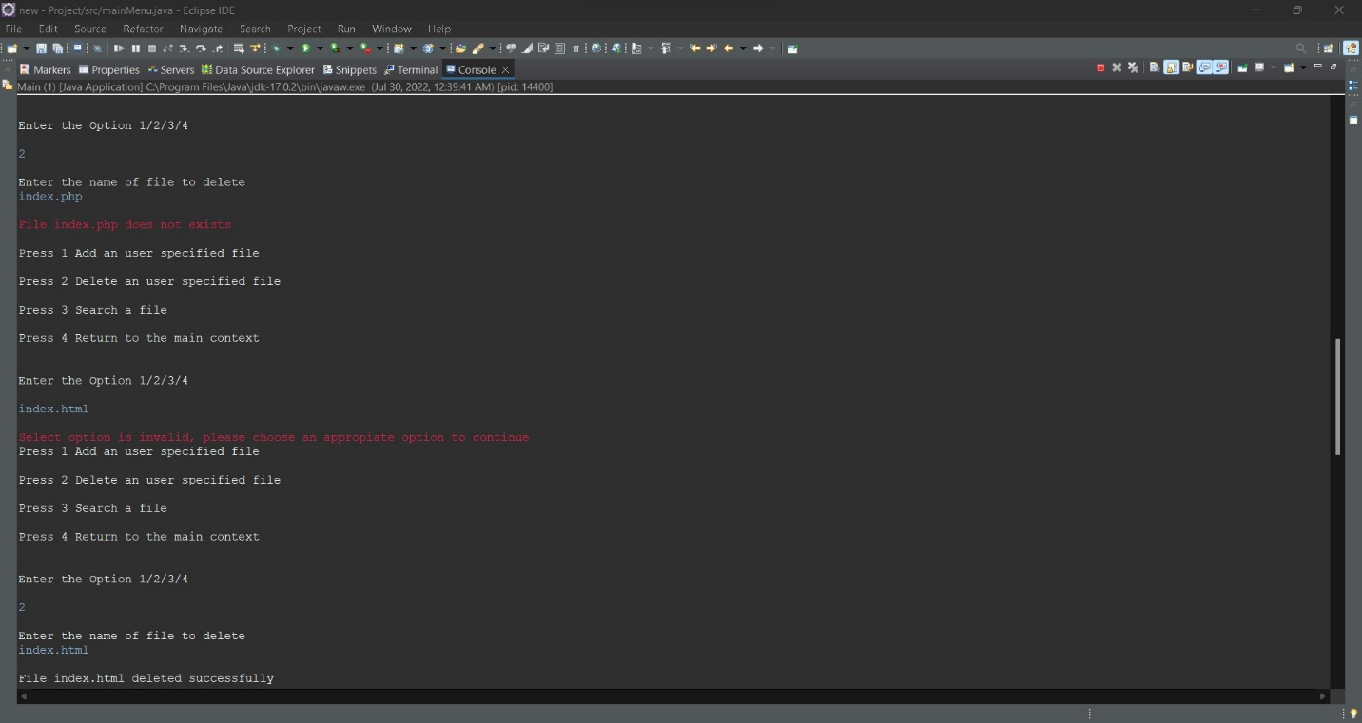

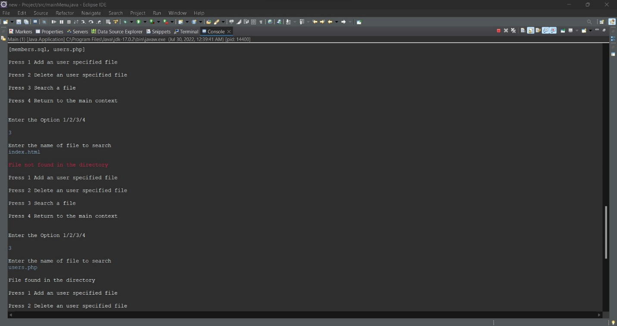

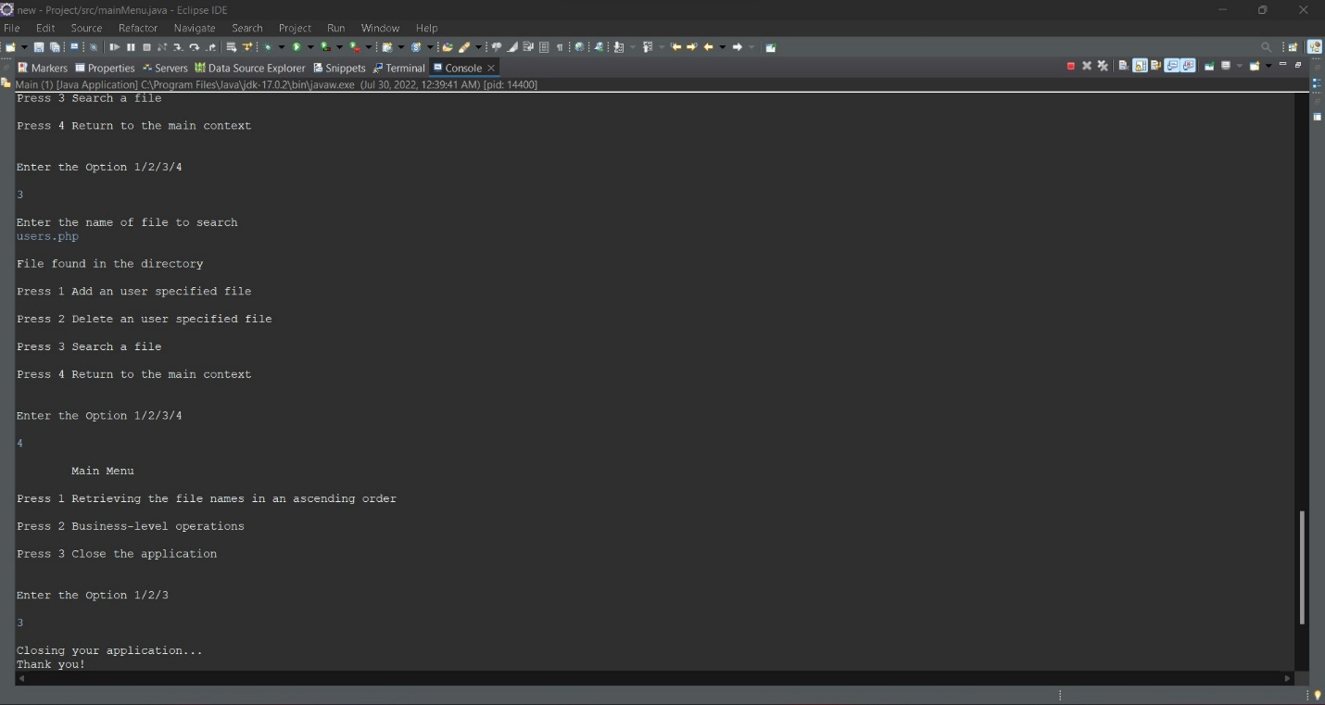

* **Unique Selling Points of the Project**
* The application doesn’t exists even after the exception or error is thrown
* The program can take any type of file name and if the file name already exists or not exists, the program will throw an appropriate exception
* **Conclusion:**

It is a project which contains the features like retrieving file names from the directory in ascending order, adding a new file, deleting a file, searching a file. In future some enhancements to the application can be made which includes writing the file, appending the file, get the date of file created, checking if file is hidden or not and many more.